Linux commands
1.Create user with name Techie and provide sudo access to user.
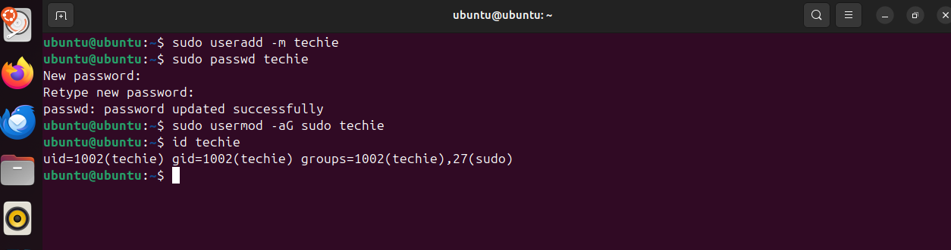

2. Navigate to the home directory.

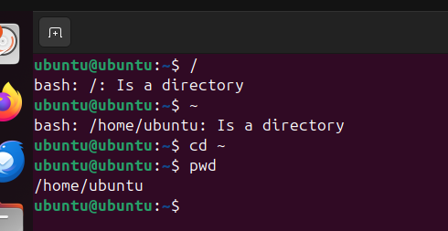

3. Create a new directory

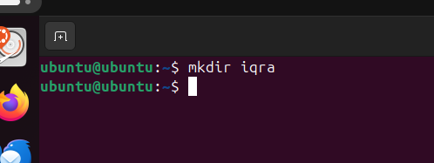

4. List the contents of a directory.

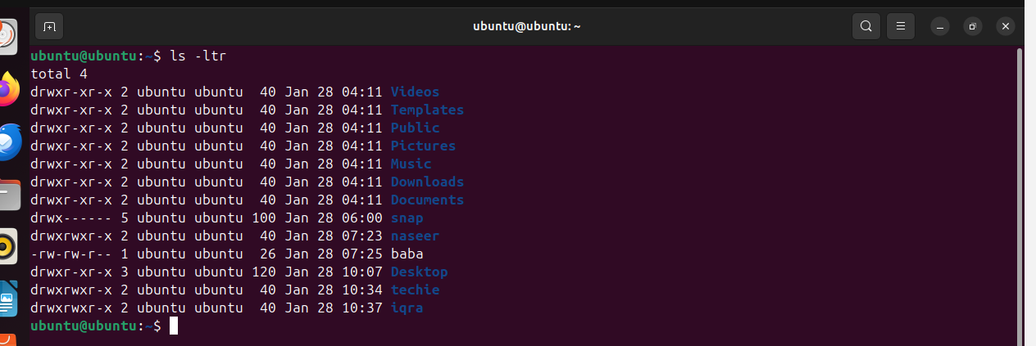

5. Change the current directory.

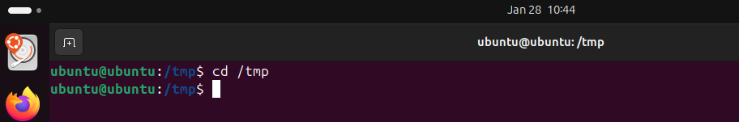

6. Create a new empty file.

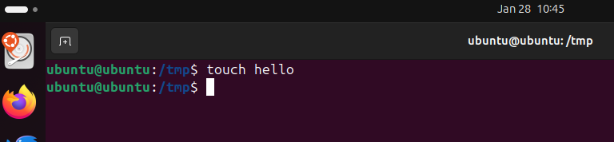

7. View the contents of a file.

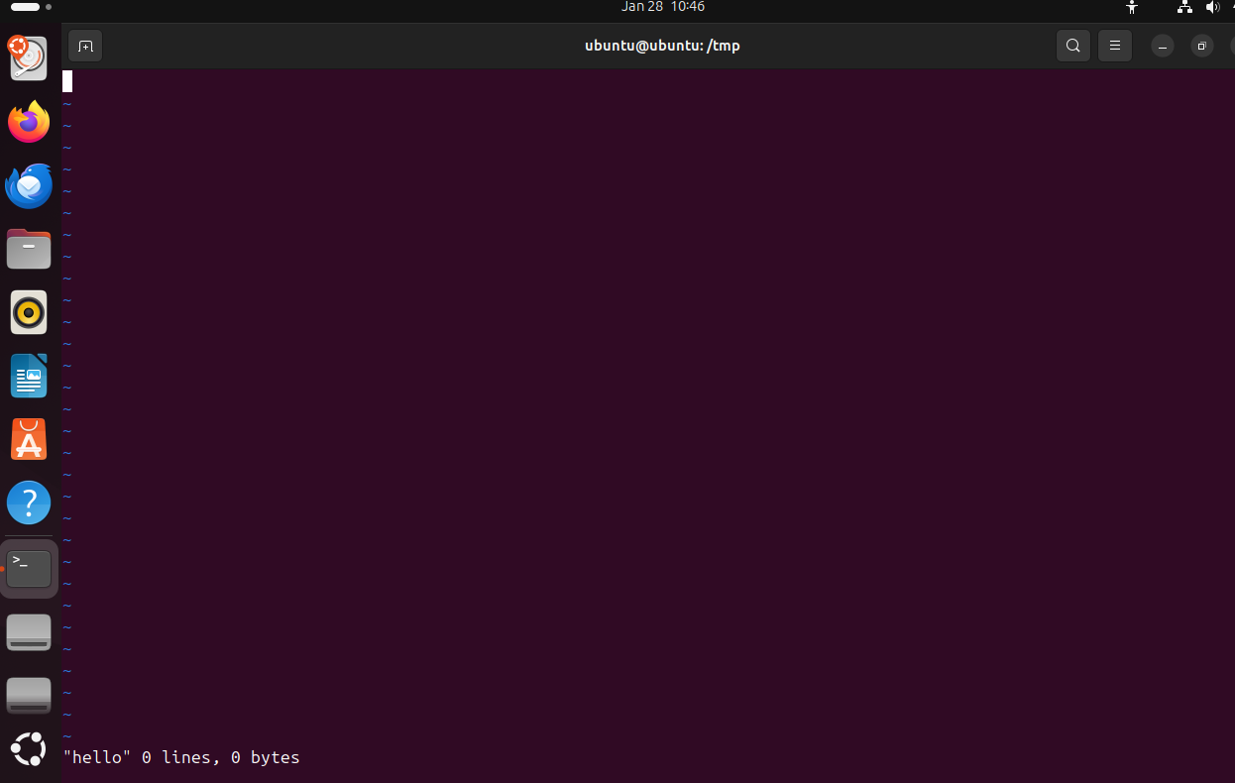

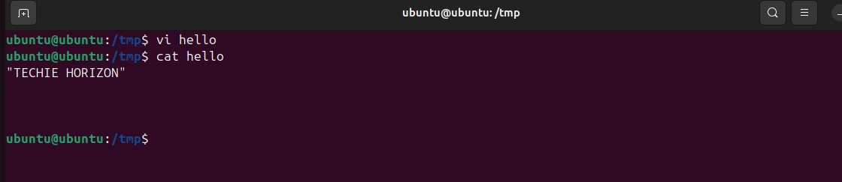
8. Copy a file to another location.
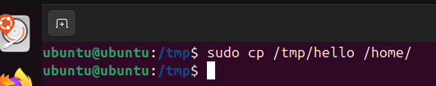

9. Move a file to another location.
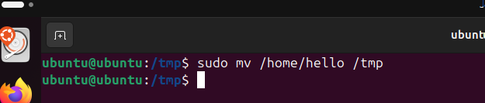

10. Rename a file.
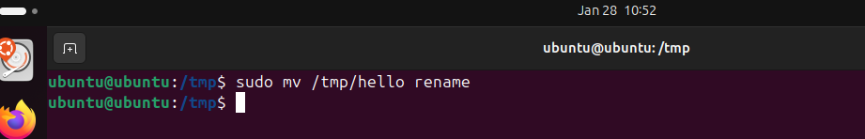

11. Delete a file.
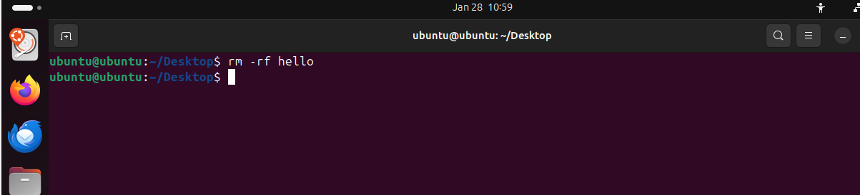
12. Grant or revoke permissions on a file or directory.
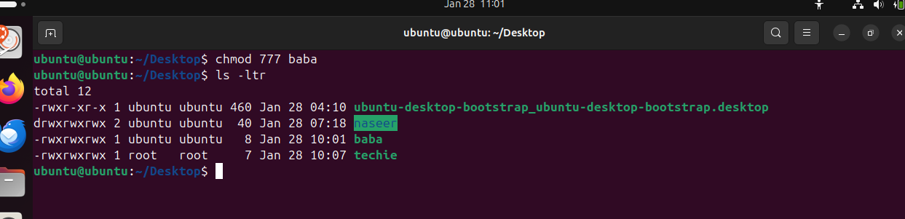
13. View the current date and time.
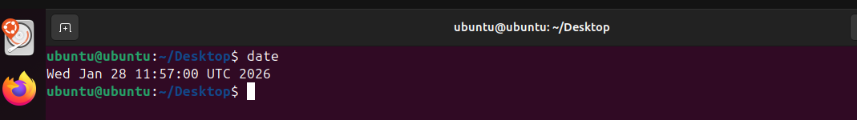
14. Check the system uptime.
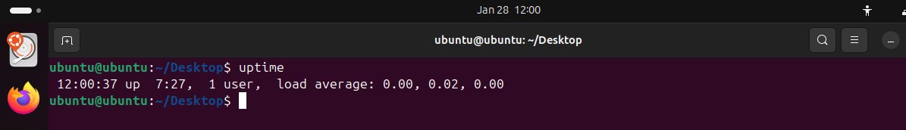
15. View the running processes.
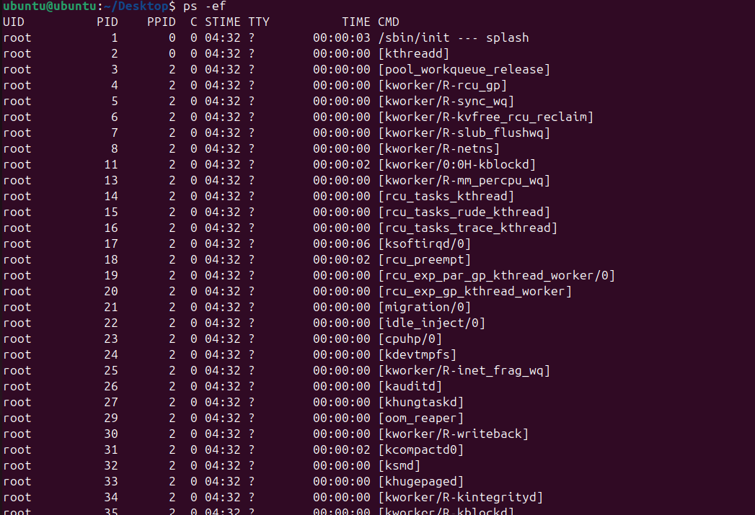
16. Kill a running process.
17. Install a package using the package manager (e.g., apt or yum).
18. Update the system packages.
- Create a symbolic link.
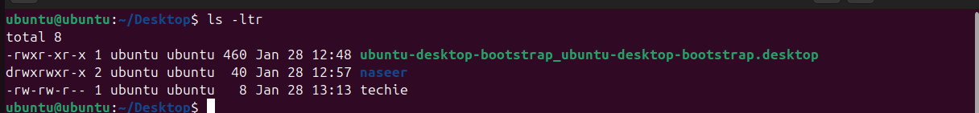
- Search for files using the find command.
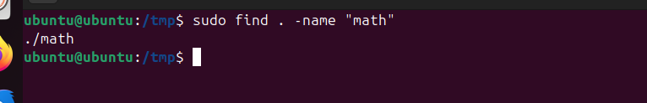
- Compress and decompress files using tar.
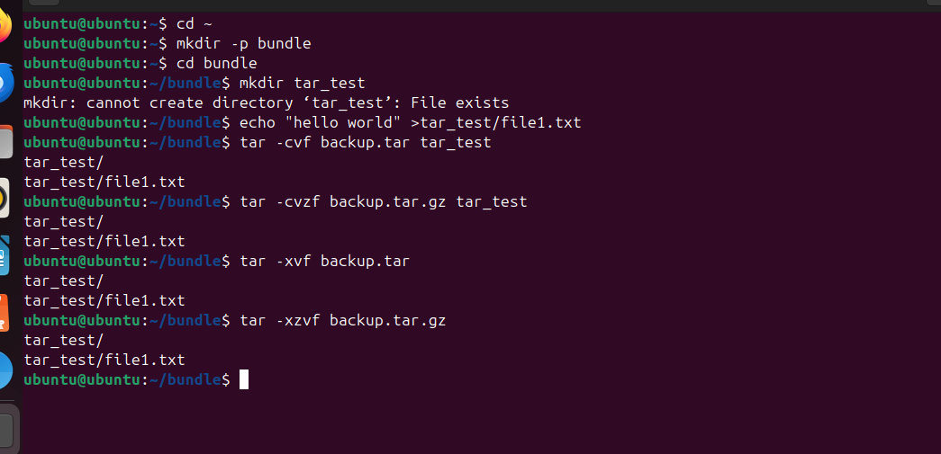
- Monitor system resources with top or htop.
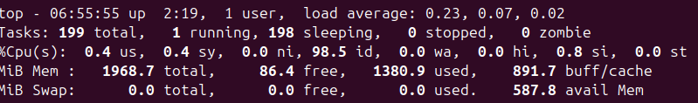
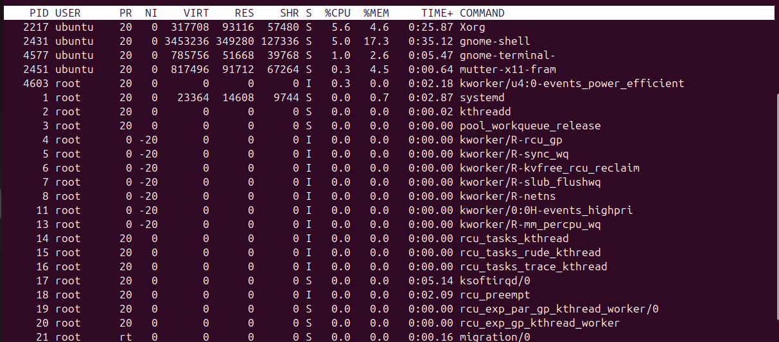
- Create and manage user groups.
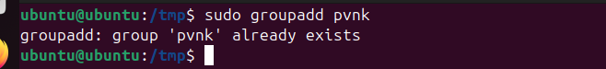
- Set up SSH password less authentication.
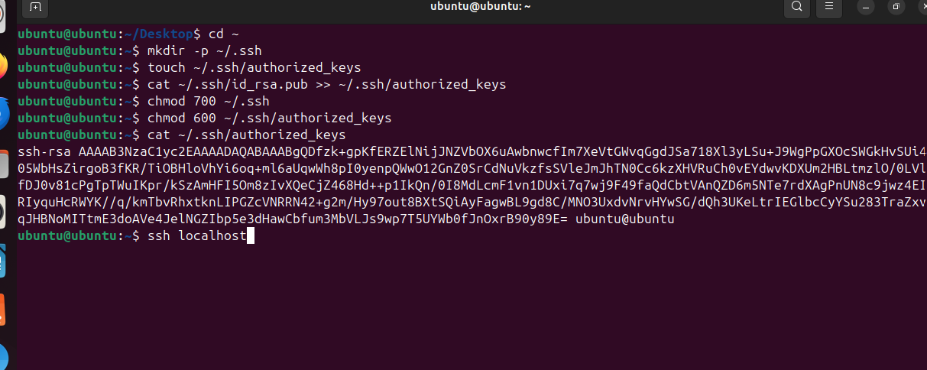
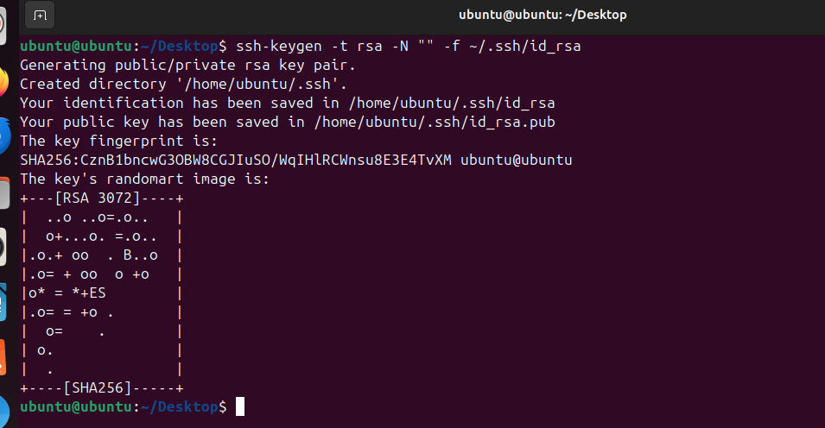
- Monitor log files using tail or grep.
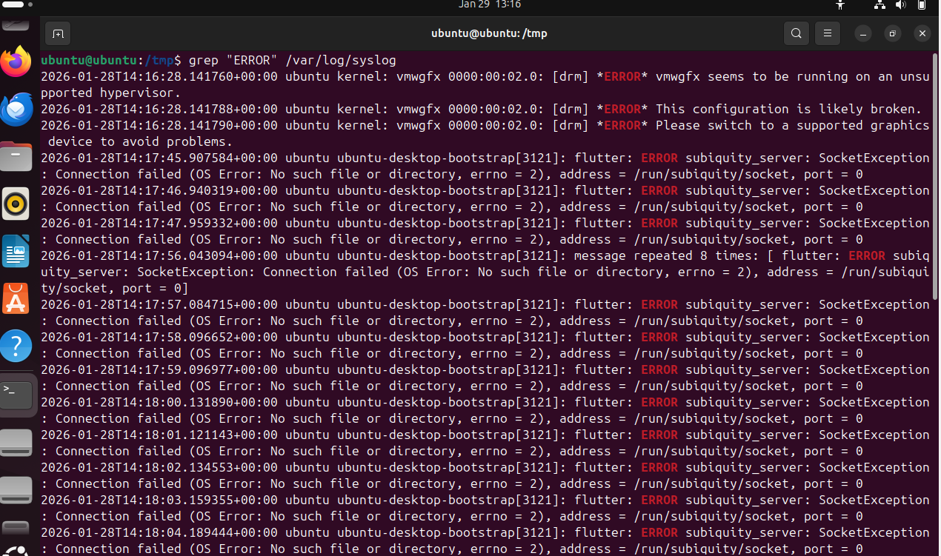

- Set up a web server (e.g., Apache or Nginx).

- Configure and secure a MySQL Database.
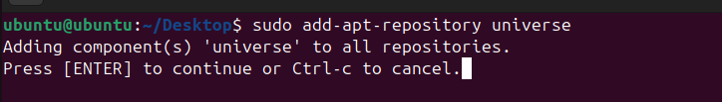
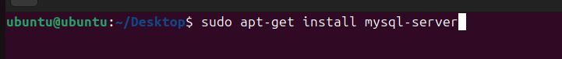
- Set up a Application Server (e.g.,Apache Tomcat)

- create a service file for Apache Tomcat.(Should execute by using systemtctl command)
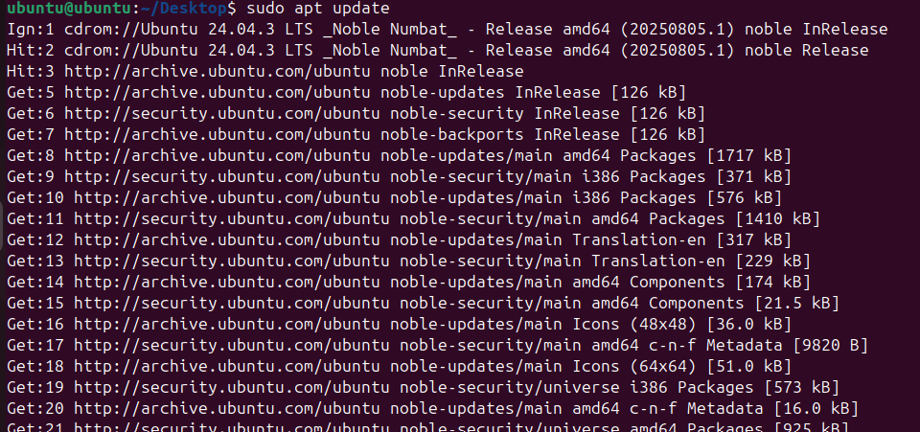
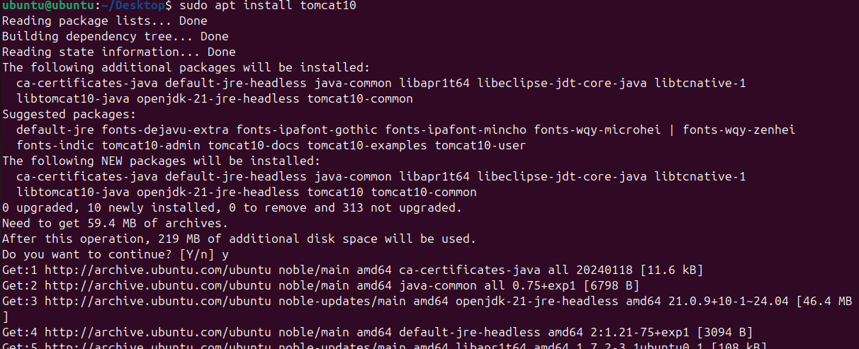
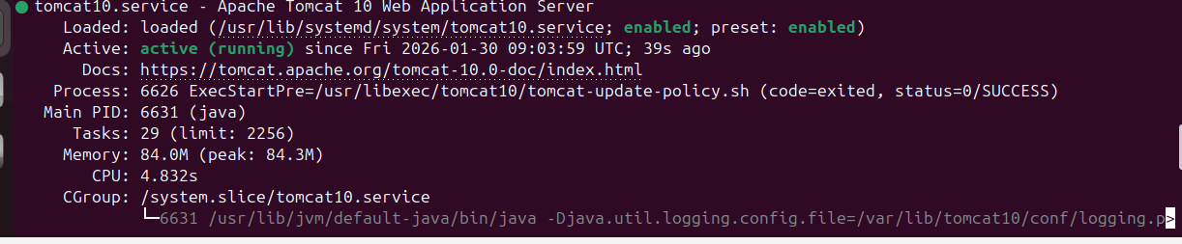
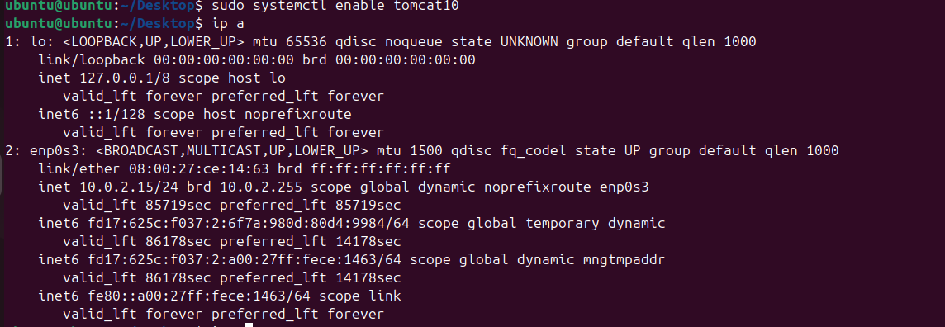

- Print specific columns from a delimited file.
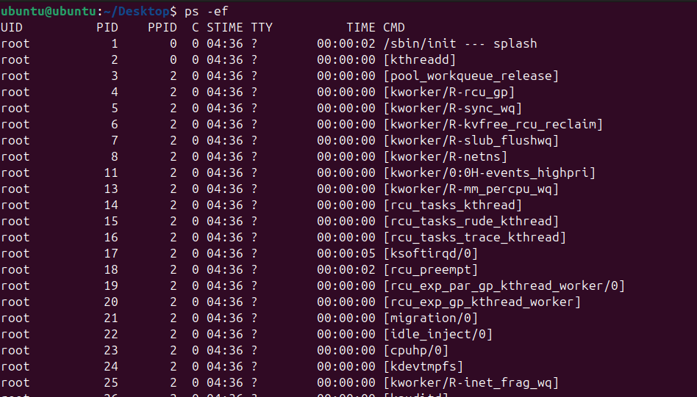
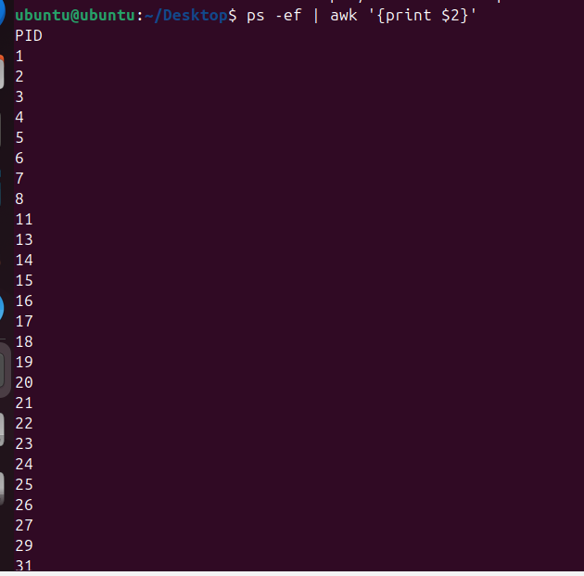

- Filter and print lines based on a specific pattern or condition.

- Calculate and print the average, sum, or other statistics of a column.
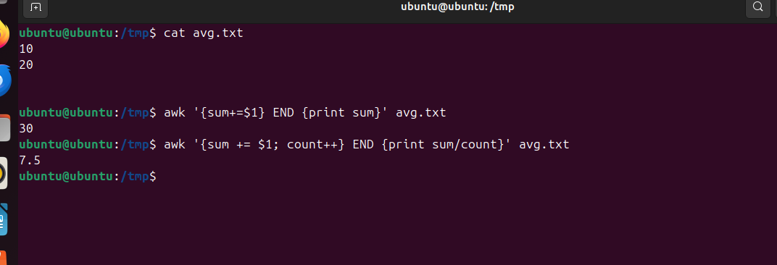

- Perform string manipulation, such as extracting substrings or changing case.
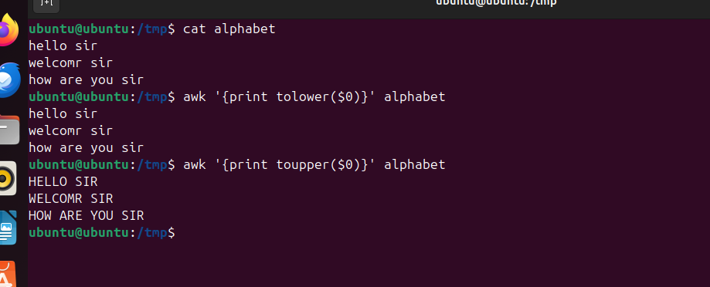
- Count the occurrences of a specific pattern in a file.
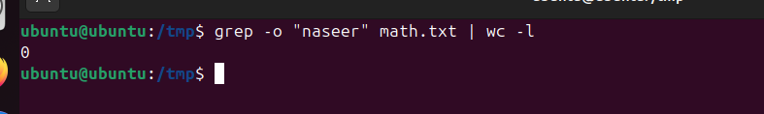
- Sort lines based on a specific field or column.
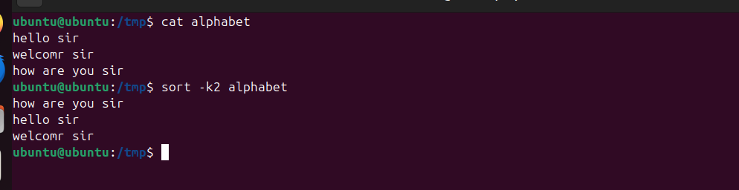

- Merge multiple files based on a common field or column.
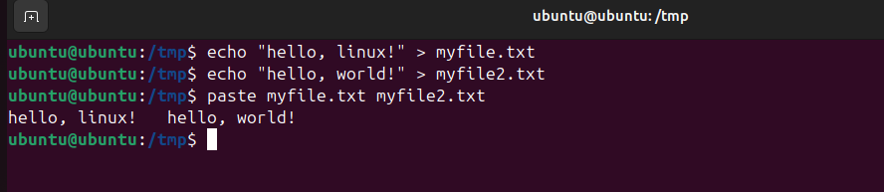
- Substitute text in a file using search and replace.
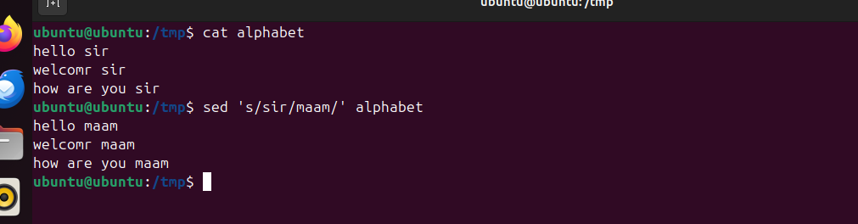

- Delete specific lines based on a pattern or line number.
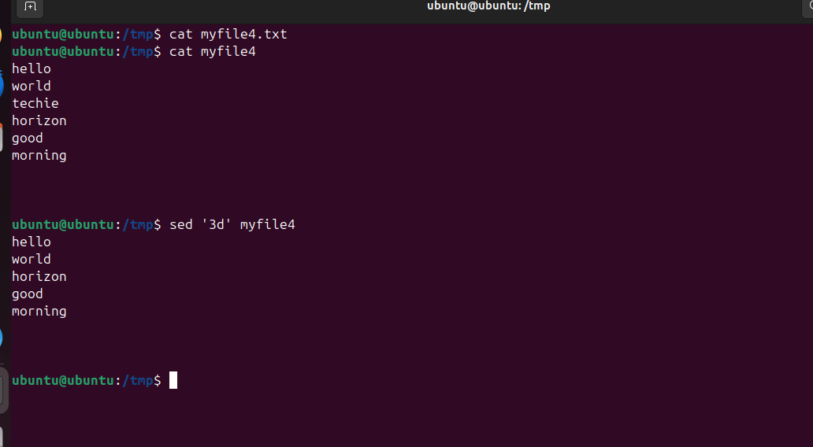
- Append or insert text before or after a specific pattern or line.
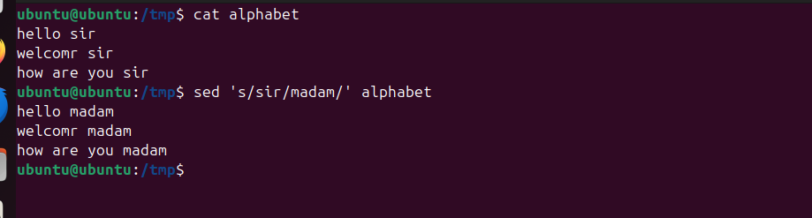
- Print only specific lines from a file.
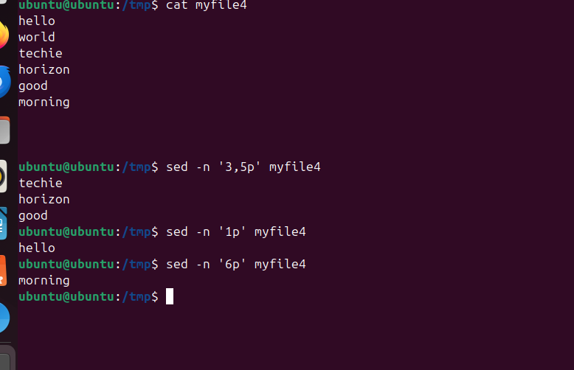
- Copy file from linux to windows machine
- 5 use cases for AWK and 5 use cases for sed
